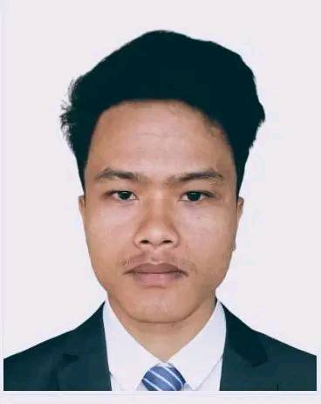**Curriculam**

**Vitae**

**Daya dhon Chakma**

*Cell No: 016020449430*

*G-mail :* *dayadhonchakma@gmail.com*

|  |
| --- |
| **Objective:** To obtain a challenging position in any area of Mechanical Sector that will provide future oportunities for growth and development and to use my skills and experience that I have acquired in my education life and to dedicate my whole effort to achieve the organization goal. |

|  |  |
| --- | --- |
| **Education**  **Qualification** | **Diploma In Engineering**  Institution : Chittagong Polytechnic Institute  Department : Mechanical  Result : 3.22 (out of 4.00)  Passing year : 2022  Board : BTEB, Dhaka |
| **Higher Secondary Certificate (HSC)**  Institution : Technical School and College, Khagrachari  Deparment : Agro Machinery  Result : 4.72 (out of 5.00)  Passing year : 2018  Board : BTEB, Dhaka |
| **Secondary School Certificate (SSC)**  Institution : Technical School and College,Khagrachari  Department : Farm Machinery  Result : 5.00 (out of 5.00)  Passing year : 2016  Board : BTEB,Dhaka |

|  |  |
| --- | --- |
| **Industrial Training** | Name of the organization : Bangladesh Railway  Address : Pahartali, Chittagong  Duration : 12 October 2022 to 3 January 2023 |

|  |  |  |  |
| --- | --- | --- | --- |
| **Language** | **Reading** | **Speaking** | **Writing** |
| Bengali | High | High | High |
| English | High | Medium | High |

|  |  |
| --- | --- |
| **Personal**  **Details** | Name : Daya dhon Chakma  Father Name : Laxmi Kanta Chakma  Mother Name : Bana Shova Chakma  Permanent Address : Vill-Birendra Para; P.O-Panchari;  P.S-Panchari; Dist-Khagrachari;  Present Address : Vill-Birendra Para; P.O-Panchari;  P.S-Panchari; Dist-Khagrachari;  Date of Birth : 12-10-1999  Nationality : Bangladeshi  Region : Buddhist  NID No : 1503116301  Blod group : B+  Hieght : 5.2”  Sex : Male  Marital Status : Unmarried |

|  |
| --- |
| **Declaration:** I would appreciated if you give me an opportunity to work with you and to excute myself with your support. All the information provided are correct and complete. |

Signature

Date:…………….